Ganesh Chaturthi: The Hindu Festival Celebrating Lord Ganesha

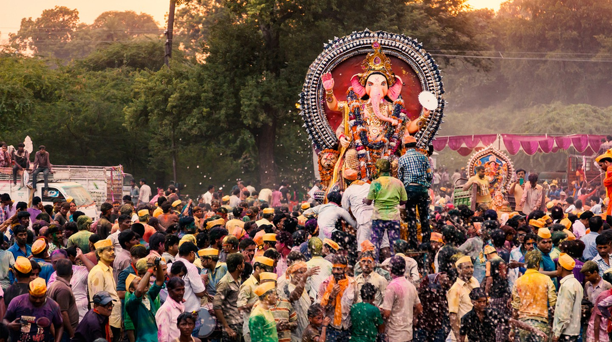

Holy Immersion ceremony | © ZIGROUP-CREATIONS / Shutterstock

Ganesh Chaturthi, also known as Vinayaka Chaturthi, is a 10-day festival that commemorates the birth of the revered Hindu god Ganesha – the harbinger of new beginnings and the remover of all evils.

Conforming to the [Hindu calendar](https://theculturetrip.com/asia/india/articles/10-hindu-festivals-you-should-know-about/), the event, dedicated to Lord Ganesha who is depicted with an elephant’s head on a human body, commences on the fourth day following the arrival of the new moon (Shukla Paksha Chaturthi) in the month of Bhadrapada, which usually falls in August or September. It ends on the 14th day of the waxing moon (bright half of the moon) called Anant Chaturdashi. Although the festival is held across the country, the most flamboyant celebrations can be seen in the western Indian states of Maharashtra and Goa; and the southern Indian states of Karnataka, Tamil Nadu and Andhra Pradesh.

The festival is believed to date back to the times when the Chalukya, Satavahana and Rashtrakuta dynasties ruled between 271 BC and 1190 AD. However, the first historical record of it is available from the 1600s in Pune, when the founder of the Maratha Empire Chhatrapati Shivaji Maharaj celebrated Ganesh Chaturthi as Lord Ganesha was considered to be their Kuladevata (family deity). In Sanskrit, *kula* refers to clan and *devata* means deity. With time, the festival lost its significance but was revived and transformed from a private celebration into a grand public event in the 19th century by Indian freedom fighter Bal Gangadhar Tilak to unite people from all walks of life.

Ganesh Chaturthi is a 10-day festival that commemorates the birth of Hindu god Ganesha [© Stuti K / WikiCommons](https://commons.wikimedia.org/wiki/File:Ganesh_Visarjan_in_Pune.JPG)

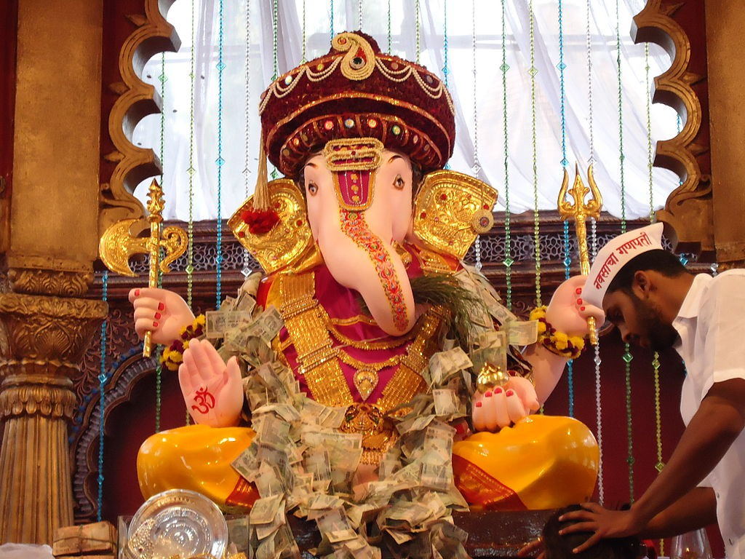

How is Ganesh Chaturthi celebrated across India?

Known by 108 names, Shri Ganesha is one of the most worshipped deities in Hinduism and is regarded as ‘the god for everybody’. In the weeks leading up to the day of his birth, sculptors can be seen making clay models of the deity in various sizes (from 3/4 inches up to 70 feet tall), while exquisitely crafted pandals (temporary tents carrying idols of gods) are simultaneously set up.

Artists working on a giant statue of Ganesh in Hyderabad © reddees / Shutterstock

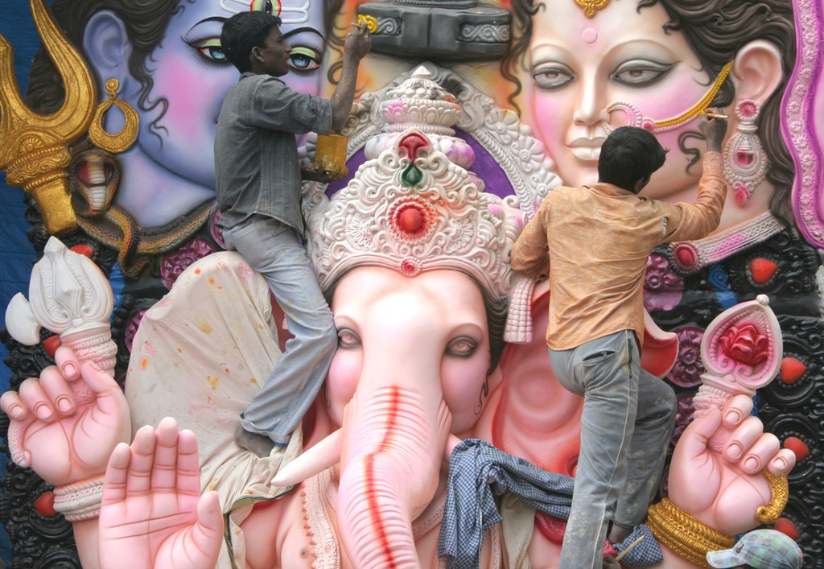

The festival begins with the installation of beautifully crafted statues of Ganesha in pandals or on an elaborately decorated platform called mandaps in homes or shops. Prayers, devotional chanting and food offerings (usually coconut, jaggery and *modaks* – a sweet dumpling believed to be Ganesha’s favourite food) are made to the idol on all 10 days. Many devotees also tend to fast during this period.

Modaks (sweet dumplings filled with jaggery and grated coconut) are believed to be Ganesha's favorite food © espies / Shutterstock

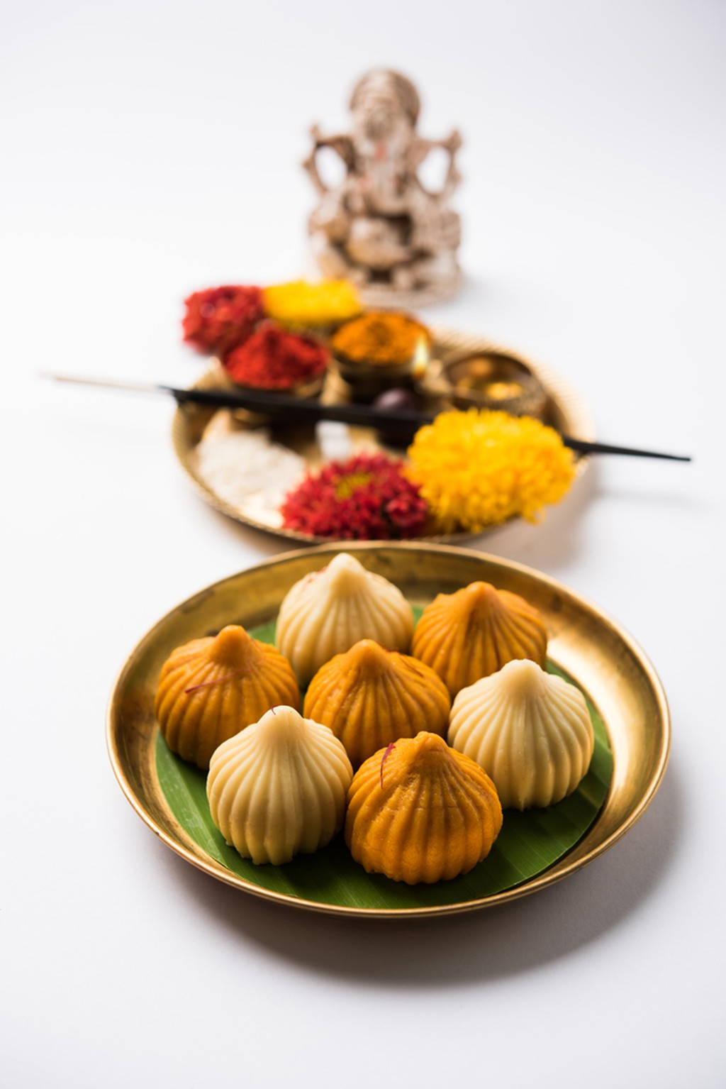

On the last day (Anant Chaturdashi), the clay models of Ganesha are paraded through the streets, accompanied by singing and dancing**,**before being dissolved in the sea or river. This ritual, referred to as Ganesha Visarjan, is carried out to return the elements back to nature since the idols are made of clay.

Ganesh being immersed © CRSHELARE / Shutterstock

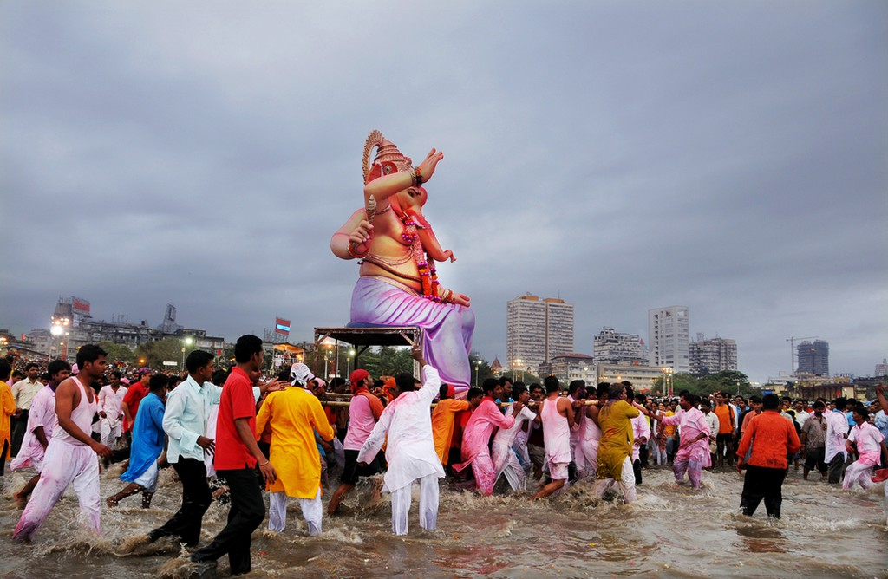

Maharashtra

[The festival is a grand affair in Maharashtra](https://theculturetrip.com/asia/india/articles/10-reasons-why-you-should-visit-the-indian-state-of-maharashtra/), especially in Mumbai and Pune. Public podiums or pandals are set up in hundreds of locations across these cities.

Mumbai

More than 10,000 pandals are built in Mumbai every year to carry large idols of the deity adorned with gold and silver ornaments, sometimes accompanied by drum beats and Bollywood music wafting out of them. Cultural events and fairs are held alongside daily prayers and offerings.

Among the cities’ many pandals, there are a few noteworthy ones that attract hundreds of thousands of devotees from across the country and beyond. The most iconic one is the Lalbaugcha Raja in Lalbaug, while other impressive structures include the Ganesh Galli Mumbaicha Raja, the GBS Seva Ganesh Mandal in King’s Circle, the Andhericha Raja in Andheri and the Khetwadi Ganraj in Girgaum. The Shree Sarvajanik Ganeshotsav Mandal at the Keshavji Naik Chawl in Girgaum is also worth getting close to as it’s Mumbai’s oldest Ganesh pandal and was created by Bal Gangadhar Tilak in 1893 to unite Indians against colonial rule.

Ganesh Chaturthi celebrations at Lalbaugcha Raja in Mumbai is the most iconic of all [© Karthikndr / WikiCommons](https://commons.wikimedia.org/wiki/File:Lalbagcha_Raja(1)_(2011).JPG)

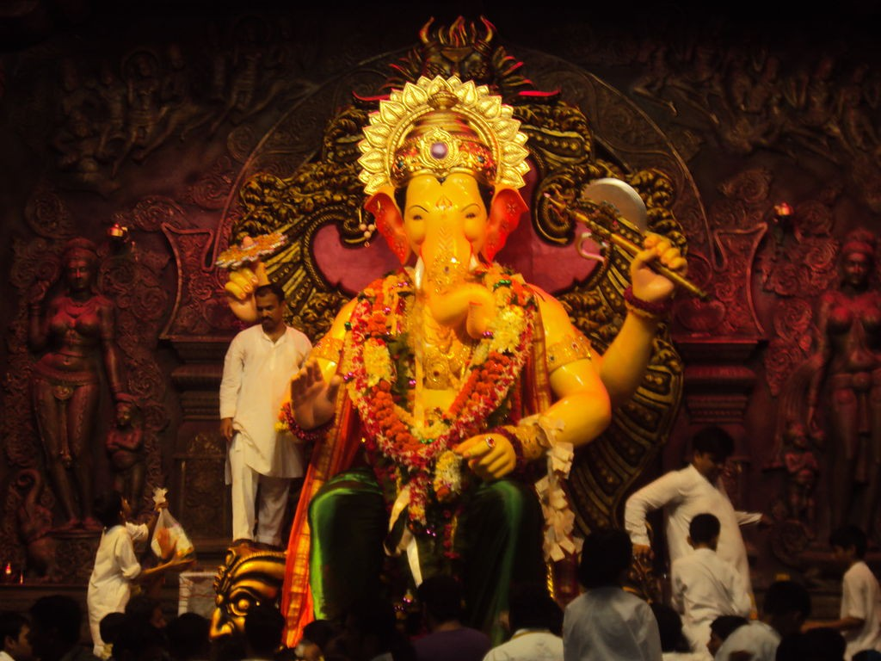

Pune

Although the traditions and rituals are similar to those in Mumbai, the city goes a step further by holding the Pune Festival as part of its celebrations. The event features classical dance, music recitals, film and drama, traditional sports, exquisite handicraft and textile displays, and automobile rallies.

The best Ganpati mandals to visit in Pune are the Kasba Ganpati Mandal (the place where the Ganesh Chaturthi in its current form was first held), the Dagadusheth Halwai Ganapati Temple (one of the richest Ganpati temples in India), the 15th-century Tambdi Jogeshwari Temple, the Tulsi Baug Ganpati, the Kesari Wada Ganpati and the Hutatma Babu Genu Ganesh Mandal Trust (famed for its wish pond).

Installation of Ganesh idol at Dagadusheth Halwai Ganapati Temple in Pune [© Chawla.nishant / WikiCommons](https://commons.wikimedia.org/wiki/File:Dagdu_Seth_Ganpati_Sthapna.JPG)

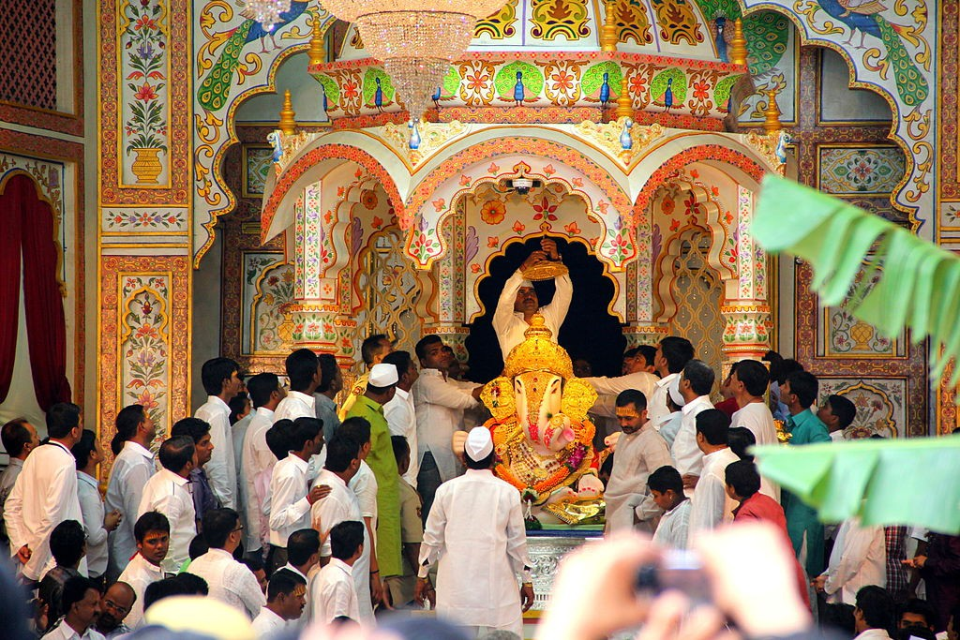

Goa

Also known as Chavath in Konkani, the celebrations in Goa last from nine up to 21 days. The idol of Ganesha is brought home, or at pandals, on the eve of Chavath. The priest performs the *puja*(prayer) and, in the background, percussion instruments, *ghumots*, crash cymbals and *pakhavaj* (India-barrel two-headed drum) are played. The highlight is the matoli or canopy under which the idol is installed. It is made from fruits, vegetables, berries and rare herbs. Women keep fast and engage in fugdi (folk dance).

The best Ganesh installations can be witnessed in the small town of Marcel, where local artisans make beautiful idols of Ganesh from unconventional materials such as coconut, cotton, rubble, ropes and wax. Other areas to witness the event are Mapusa and Panjim.

Celebrations in South India

In South India, especially in Karnataka, Tamil Nadu, Andhra Pradesh and Kerala, the festival is also known as Vinayaka Chaturthi. Here, locals also celebrate Gowri Habba, which takes place just a day before Ganesh Chaturthi. It is a festival dedicated to Goddess Gauri (also known as Parvati), wife of Lord Shiva and mother of Lord Ganesha. The next day, the idols of Lord Ganesha are installed throughout the states for communal worship.

Along with 21 pieces of *modaks* (called kozhukkatta in Tamil Nadu, modakam or kudumu in Andhra and kadubu in Karnataka), elaborate feasts are held highlighting the regions’ traditional dishes. In Karnataka, *panchakajjaya* (a sweet made with desiccated coconut, sugar, ghee, sesame seeds and gram dal) is also offered to Lord Ganesha.

The best locales to see the grand celebrations include the Kanipakam Vinayaka Temple in Chittoor (Andhra Pradesh), the Karpaka Vinayakar Temple in Tiruppathur (Tamil Nadu), Khairatabad Ganesh in Khairatabad (Hyderabad, Telangana) and [Bangalore Ganesh Utsav](http://www.bgu.co.in/) at the APS College Grounds in Basavanagudi (Bangalore, Karnataka).

Ganesha Utsav in Bangalore [© Ashwin Kumar / WikiCommons](https://commons.wikimedia.org/wiki/File:Ganesh_Utsava_(8023369585).jpg)

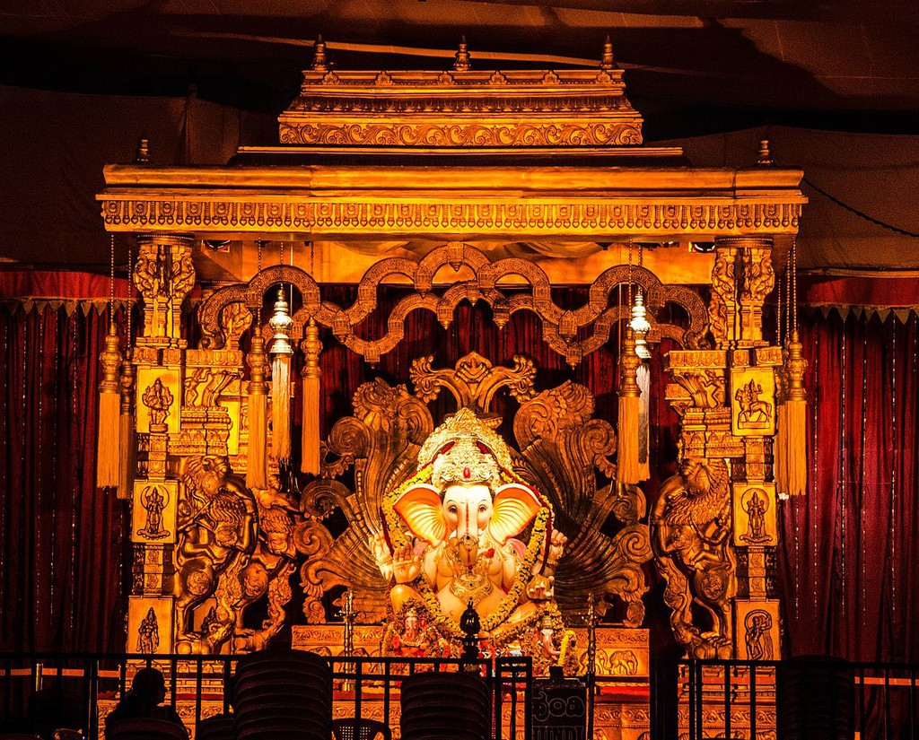

The festival is also known as Lamboodhara Piranalu in Kerala. Some years, the festivities here begin a month in advance due to differences in its calendar to that of other states. Regardless, massive clay idols and visarjan – or immersion – are carried with the same pomp and excitement, especially in its capital city, Thiruvananthapuram. Here, a huge procession from the Pazhavangadi Ganapathi Temple to Shankumugham Beach is carried out on the last day, accompanied by dancing and singing.

A huge procession from Pazhavangadi Ganapathi Temple to Shankumugham beach is carried out on the last day in Thiruvananthapuram [© Thejas Panarkandy / Flickr](https://www.flickr.com/photos/thejasp/9714901325)

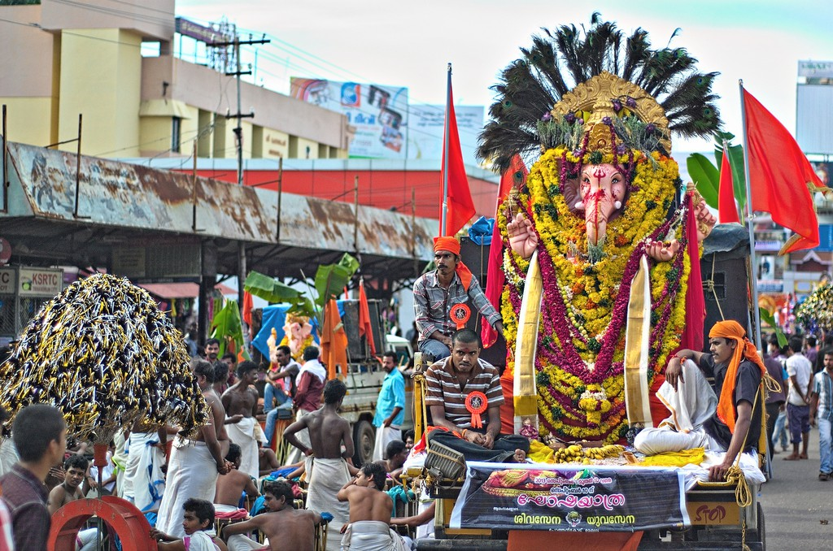

With a Hindu diaspora in almost every corner of the world, Ganesh Chaturthi is celebrated with fervour in several other countries, including Mauritius, Canada, the UK, USA, Trinidad and Nepal.

Legends surrounding the festival

The day commemorating the birth of Lord Ganesh is shrouded in legends, with the most famous one associated with Goddess Parvati, the mother of Lord Ganesha. According to the myth, Parvati created Ganesha from the turmeric paste that she had used for bathing. She breathed life into him and set him to guard the entrance while she was having a bath. Unaware of this, Lord Shiva tried to enter but was stopped by Ganesha. This enraged Shiva and he beheaded him.

Learning that her son was dead, Parvati was overwhelmed with grief and rage and asked her husband to bring her son back. Shiva requested one of his followers to get the head of the first creature lying dead with its head facing north. The follower came back with the head of an elephant. Lord Shiva fixed it on Ganesha’s body and brought him back to life.

Images of Lord Shiva, Goddess Parvati and their son, Lord Ganesha [© VedSutra / WikiCommons](https://commons.wikimedia.org/wiki/File:Shiva_Parvati_Ganesha_Images_-_A_statuette_representing_Lord_Ganesh_and_his_father_Lord_Shiva.jpg)

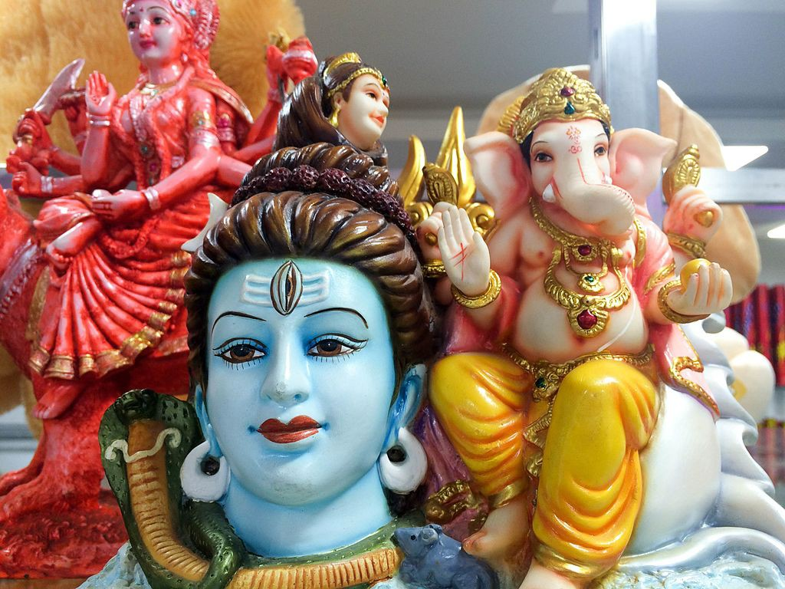

Others also believe that the moon had once laughed at Ganesha after witnessing him travelling on his vehicle – a mouse – following a night of heavy feasting. This offended Ganesha and in anger, he cursed the moon. Though Ganesha later revoked his curse after being persuaded by other gods, he maintained that no one on earth was to look at the moon on the day of Chaturthi (fourth day of the lunar month). According to the devotees, the repercussions of doing so may include having to face false allegations or unjust criticism.